α

The Alpha Software Development Team

Project Charter – v1.0

Prepared By:

Hussain Farbotko-Merabaksh, Project Leader,

Nicolas Castilloux,

Curtis Collins,

Anthony Guevara,

Patrick Ings,

Brian Reed

Project Authorized Start Date: January 23, 2012

Charter Submission Date: January 23, 2012

Contents

1. Purpose 3

2. Team Composition and roles 3

2.1 Core: 3

2.1.1 Project Team Leader: 3

2.1.2 Project Group Members: 3

2.1.3 Client: 3

3. Team Mission 3

4. Goals and Objectives 4

5. Measurement of objectives and process/ Success Metrics 4

6. Authority or boundary conditions (empowerment) 4

6.1 Resources available/needed 4

7. Timeline 5

8. Team Operations 6

9. Special Issues 6

9.1 Outstanding Issues 6

10. Commitment to the Charter 7

10.1 Charter Approval Page 8

# Purpose

The purpose of this charter to remind the team of the ultimate goal made for this project. Successful delivery of a product negotiated with The Alpha Development Team and it their Client.

# Team Composition and roles

## 2.1 Core:

### 2.1.1 Project Team Leader:

Hussain Farbotko Merabaksh

[hmerabaksh@gmail.com](mailto:hmerabaksh@gmail.com)

Project Leader

### 2.1.2 Project Group Members:

|  |  |
| --- | --- |
| Nicolas Castilloux  [nick.castilloux@gmail.com](mailto:nick.castilloux@gmail.com)  Emotional Support, Developer | Curtis Collins  [wcurtiscollins@gmail.com](mailto:wcurtiscollins@gmail.com)  Developer, Arrogant |
| Anthony Guevara  [anthony.guev@gmail.com](mailto:anthony.guev@gmail.com)  Developer, Healthy Eating Counselor | Patrick Ings  [PatrickIngsJr@gmail.com](mailto:PatrickIngsJr@gmail.com)  Developer, LoL Counselor |
| Brian Reed  [brianreed23@gmail.com](mailto:brianreed23@gmail.com)  Developer, Marriage Counselor |  |

### 2.1.3 Client:

Edmund Strange

Algonquin College

strange@algonquincollege.com

# Team Mission

Our team mission is to produce a product that our client has asked for. Achieve Client Satisfaction, Academic Satisfaction and Self Satisfaction through our hard work and dedication. It is absolutely imperative for our team to succeed.

<http://www.algonquincollege.com/employmentontario/college.htm> (Algonquin’s Mission Statement)

# Goals and Objectives

Academic Success:

Achieve an overall group mark of A.

Software Engineering Success:

Learn the process of developing projects for clients from start to finish

Client Success:

Achieve Client Satisfaction through developing a product ask for.

Personal Success:

Working in a team of great people working together to one common goal.

# Measurement of objectives and process/ Success Metrics

Our team plans to use Gmail and Google Docs to communicate, organize and process our thoughts, ideas and works to a successful end. This feature will be used on a weekly basis to ensure communication and organization is our top priority.

Personal Smart Phones to communicate ideas and updates for quick process.

# Authority or boundary conditions (empowerment)

The Project will not exceed the devices’ boundary threshold. It will not require more system resources than allocated with device capabilities. The project will adhere to scheduled time constraints and will be completed within allotted time constraints negotiated at initial meeting with client. Upgrades, or change of features may be discussed for upcoming projects.

## Resources available/needed

We will require a meeting room, to formally meet with our client.

# Timeline

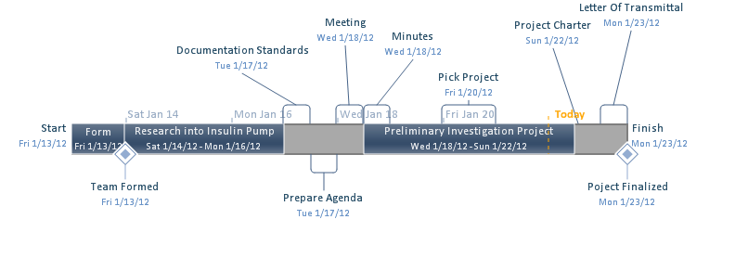

We are planning to finish preliminary investigation by Monday, January 23rd, 2012. During this period of time we will be meeting a couple of milestones, the first milestone is the formation of the team, and our second one is finalizing the preliminary investigation. Along the way we will be completing the Documentation Standards on Tuesday, January 17th, 2012, having a meeting with the client on Wednesday, January 18th, 2012, and delivering the minutes by the end of the day.

# Team Operations

The team will follow the underlining rules and obligations in order to accomplish the goals:

* The team will have equal distribution of time and effort made for their perspective tasks with
* the rest of the team.
* The team will communicate via, Gmail, Google Docs, Cellphone and Face to Face Meetings.
* The team will meet regularly Monday Afternoon between 1pm and 4 pm. The team will also communicate via online means Tuesdays and Thursdays at 7:00 pm for 30 minutes. Attendance
* is not mandatory, emails will be dispensed to all after meeting of Minutes.
* The team will use a democratic voting system to determine decision making, and to help resolve conflict, we will initiate compromise.
* During meeting cell phone calls and text messages will be ignore, unless urgent.
* The team will request Faculty intervention when the team reaches a deadlock and have no other direction to take in working to a resolution.
* Member evaluation sheets for the Project lead will be administered at the end of assignment.
* Depending on the language decided by both client and the team, an IDE will be determined.
* Gmail will be used to distribute information to clients and team personnel.
* This agreement will support the Project Leaders authority to guide and direct this team
* to success.
* During each meeting, two members will take minutes to document all discussion and
* points made.
* The team will lightly confront members who’s work is not up to group standards. Second offences
* will be of a more serious nature. Third, Faculty will be notified.

# Special Issues

We assume that the client will provide various hardware device samples to research and test for.

## 9.1 Outstanding Issues

No outstanding Issues.

# Commitment to the Charter

The Alpha Development Team created this charter and agree to adhere to and be accountable for

following its spirit and content. Agreement is shown through signing below.

________________________ _______________________ ___________

Team Leader’s name Team Leader’s signature Date

________________________ _______________________ ___________

Team Member’s name Team Member’s signature Date

________________________ _______________________ ___________

Team Member’s name Team Member’s signature Date

________________________ _______________________ ___________

Team Member’s name Team Member’s signature Date

________________________ _______________________ ___________

Team Member’s name Team Member’s signature Date

________________________ _______________________ ___________

Team Member’s name Team Member’s signature Date

## 10.1 Charter Approval Page

The charter has been reviewed and approved by:

________________________ _______________________ ___________

Project Professor’s name Project Professor’s signature Date

**Appendices**

Appendix A: Gantt Chart for overall project (CST8151 and CST8160)